Fibers- Weave Note Guide

Fibers

* Considered _______________________ evidence.
* Have probative value.
* Are common trace evidence at a crime scene
* Can be ___________________________ based on comparison of both physical and chemical ___________________________________.

Fabric

* Fabric is made of ______________________. Fibers are made of twisted filaments.
* Types of fibers and fabric
  + _____________________- animal, vegetable or inorganic
  + _____________________- synthesized or created from altered natural sources

Types of Fibers

* Synthetic- ______________________________________________________________
* Natural- ________________________________________________________________

Fabric Production

* Fabrics are composed of __________________ threads or yarns, made of fibers that are knitted, woven, bonded, crocheted, felted, knotted or laminated. Most Most are either woven or knitted.
* The degree of _________________, absorbency, water repellence, softness and durability are all individual qualities of the different fabrics.

Weave Terminology

* ____________________- a continuous strand of fibers or filaments, either twisted or not.
* ____________________- lengthwise yarn
* ____________________- crosswise yarn
* ____________________- a fabric made up of two or more different types of fiber.

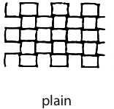Plain Weave

* The ________________ and most ________________ weave pattern.
* The warp and weft yarns pass under each other alternately
* Design resembles a checkerboard.

Twill Weave

* The warp yarn is passed over ______ to _______ weft yarns before going under one.
* Makes a diagonal weave pattern.
* Design resembles stair steps.
* 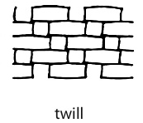___________________ is one of the most common examples.

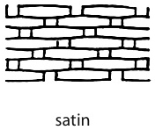Satin Weave

* The yarn interlacing is not uniform.
* Creates long floats.
* Interlacing weave passes over _________ or more yarns.
* ___________________ is the most obvious example.

Knitted Fabric

* 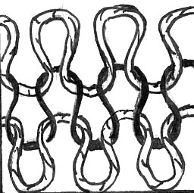Knitted fabrics are made by __________________ loops into a specific arrangement. It may be on continuous thread or a combination. Either way, the yarn is formed into successive rows of loops and then drawn through another _________________ of loops to make the fabric.

Polymers

* ____________________ fibers are made of polymers which are long chains of repeating chemical units.
* The word ________________ mean many (poly), units (mer).
* The repeating units of a polymer are called _____________________________.
* By varying the chemical structure of the monomers or by varying the way they are joined together, polymers are created that have different properties.
* As a result of these difference, forensically they can be __________________ from one another.

Filament Cross- Sections

* Synthetic _______________ are forced out of a nozzle when they are hot, and then they are woven. The holes of the nozzle are not necessarily round; therefore, the fiber filament may have a unique cross-section.

Testing for Identification

* ________________________________ observation
* _______________________- observing of how a fiber burns, the odor, color of flame, smoke and the appearance of the residue.
* ______________________________________- gently heating to break down the fiber to the basic monomers.
* _______________________________- solubility and decomposition

Dyes

* Components that make up dyes can be ______________________ and matched to an unknown.
* There are more than _______________ different dye formulations.
* ___________________________ is used to separate dyes for comparative analysis.
* The way a fabric accepts a particular dye may also be used to identify and compare samples.